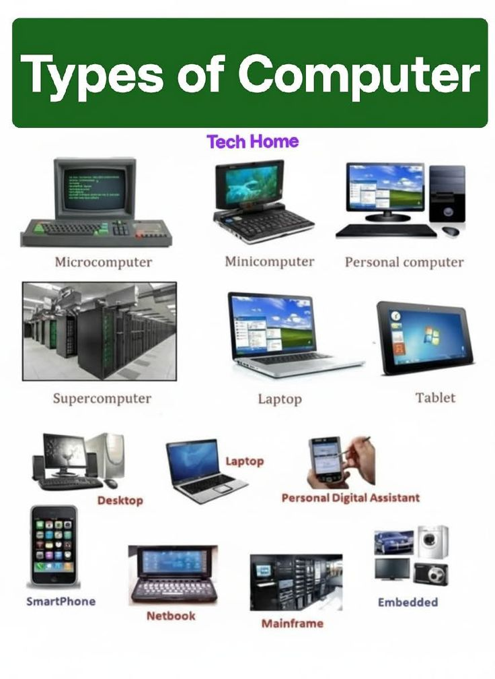
CLASSIFICATION OF COMPUTERS

